**Test Executions**

* We would be running
  + unit tests (test code by writing code) => developers
  + integration tests
    - unit test
    - ui test
    - api test
  + Functional tests
    - ui tests (simulate user) => selenium, cypress, qtp…
    - api tests (postman, rest assured)
  + Performance tests:
    - load testing harness (jmeter, load runner)

TO add repository from local to remote repository

* first clone the git repository to the local system using powershell.

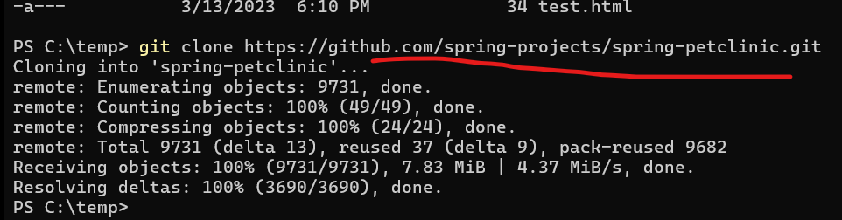

* Go to that repository

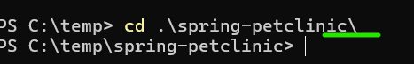

* Check the branch of the repository in which you are.

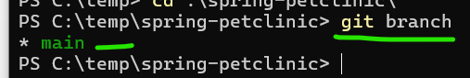

* add new repository to arure devpos repos.

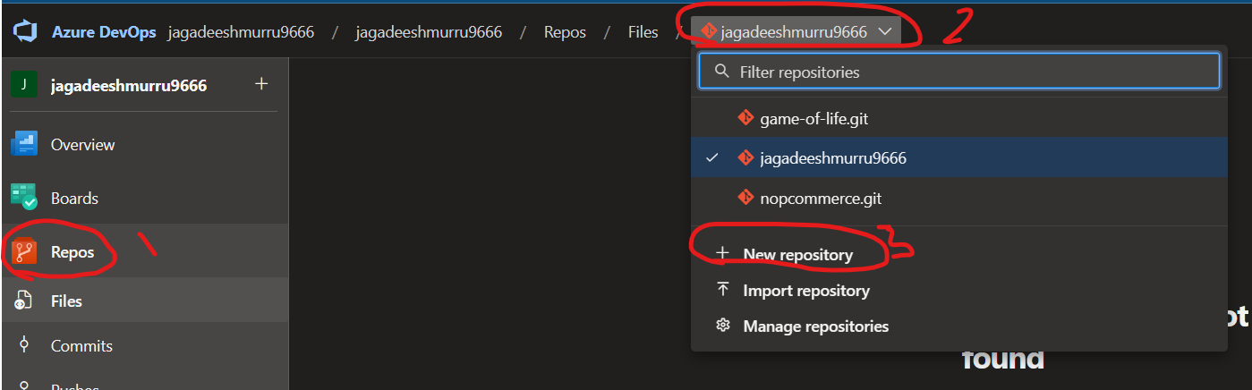

* enter the name you want for the repository.

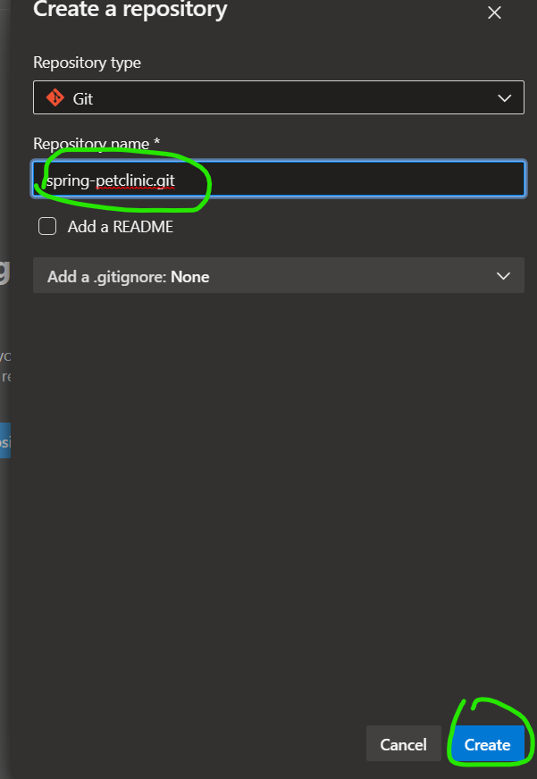

* copy the ssh path
* 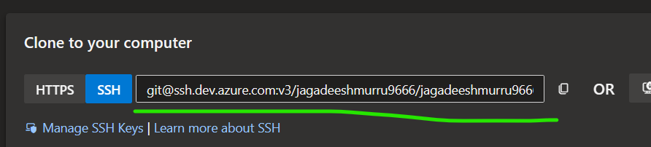
* Enter the below command

`git remote add <give name just for reference> <ssh-path-of repos>



* Now push the repository with reference name given above and branch you want.

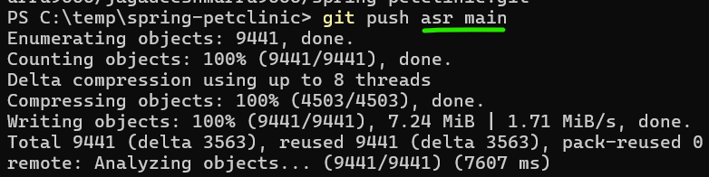

* Now repository is present.

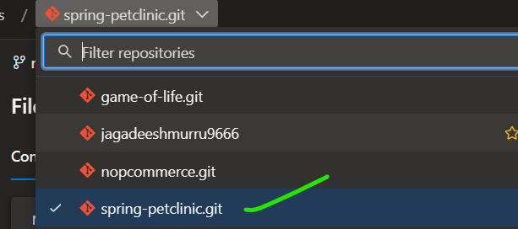

Create a self hosted agent

* Create an ec2 instance
* Go to project settings

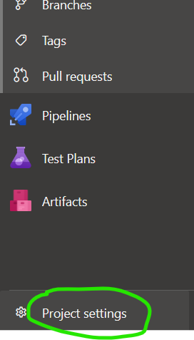

* Select agent pools and select default

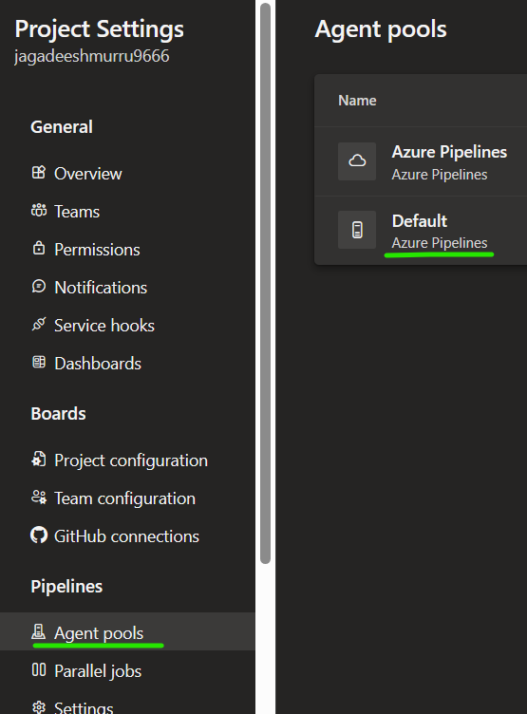

* Go to agents and select new agent

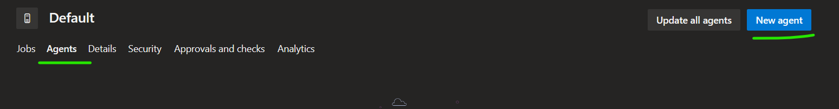

* Select linux

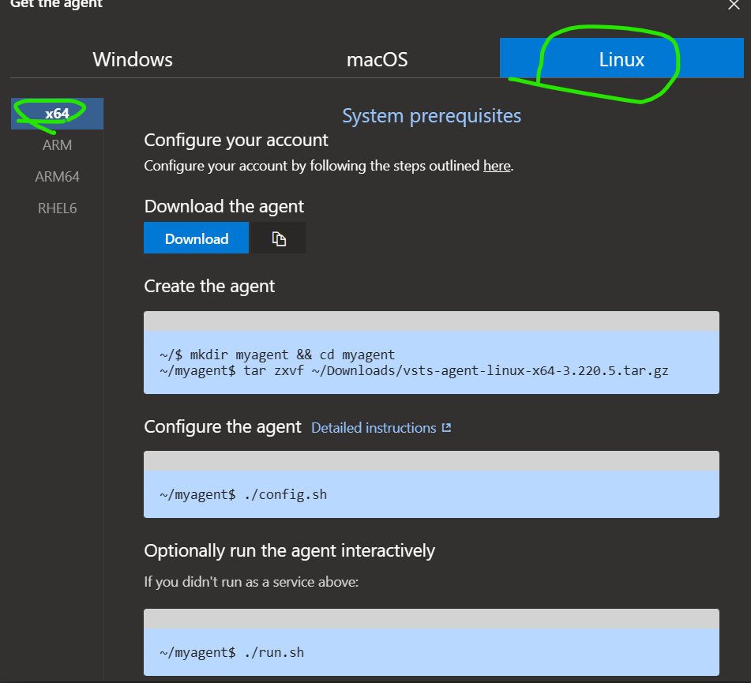

* Copy the agent

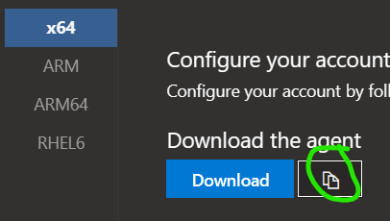

* Now in linux machine enter `wget <paste the code>`

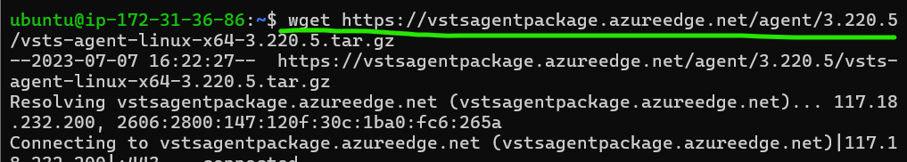

* Now execute the below commands

‘’ mkdir myagent && cd myagent

tar xvzf ~/vsts-agent-linux-x64-3.220.5.tar.gz

./config.sh

./run.sh “

NOTE:

While executing ./config.sh command you need to give some permissions.



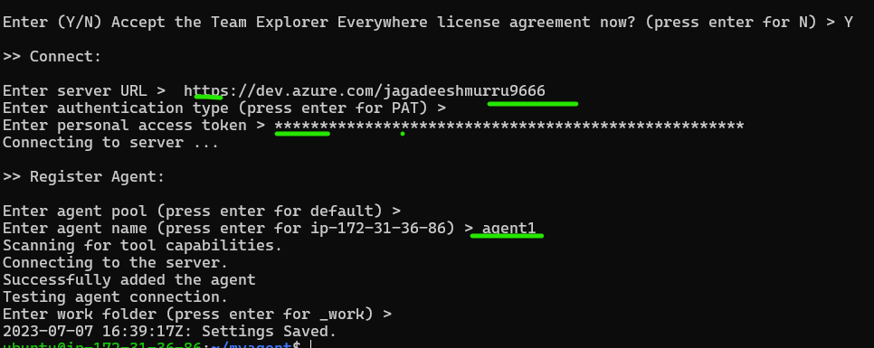

* To run the agent

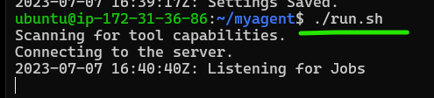

* Azure DevOps Pipeline values that are passed before execution is parameter and variables are set and modified during pipeline execution.

## Variables in Azure DevOps Pipelines

* Azure DevOps Pipeline has variables, we can assign values to be used within pipeline across stages, jobs or steps.
* Variables values can be changed during the pipeline execution
* Pipeline execution has 3 phases
  + Queue time phase
  + Compile phase
  + Runtime phase
* Variables can be used by 3 different expressions [Refer Here](https://learn.microsoft.com/en-us/azure/devops/pipelines/process/variables?view=azure-devops&tabs=yaml%2Cbatch#user-defined-variables)
  + macro $(var)
  + template ${{ variables.var }}
  + runtime expression $[variables.var]